Endpoint
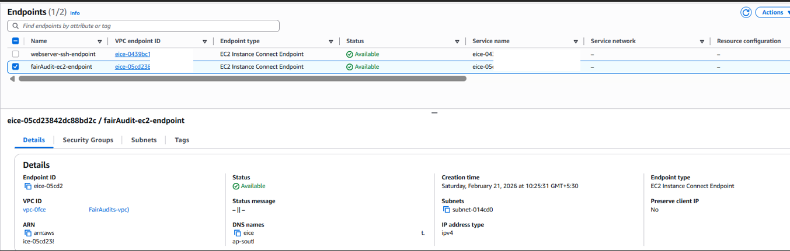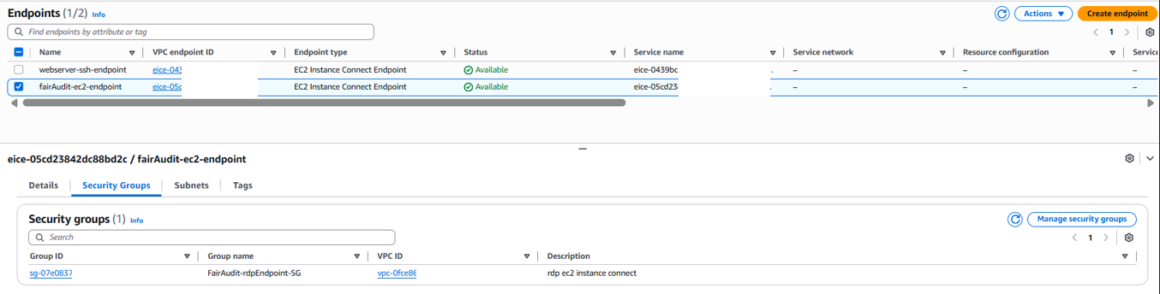

Security Group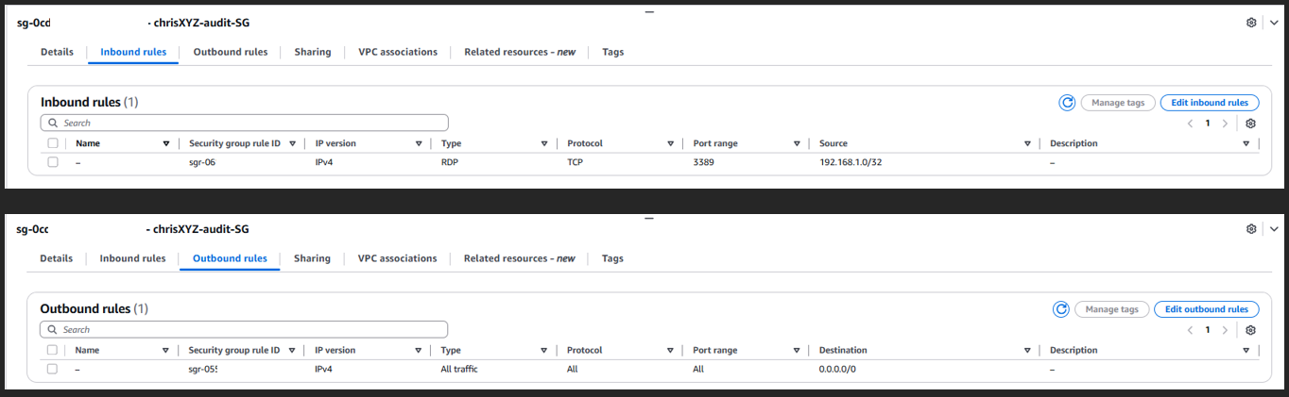
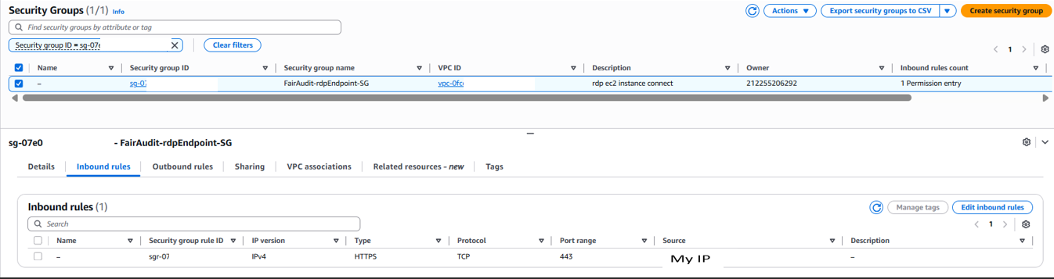
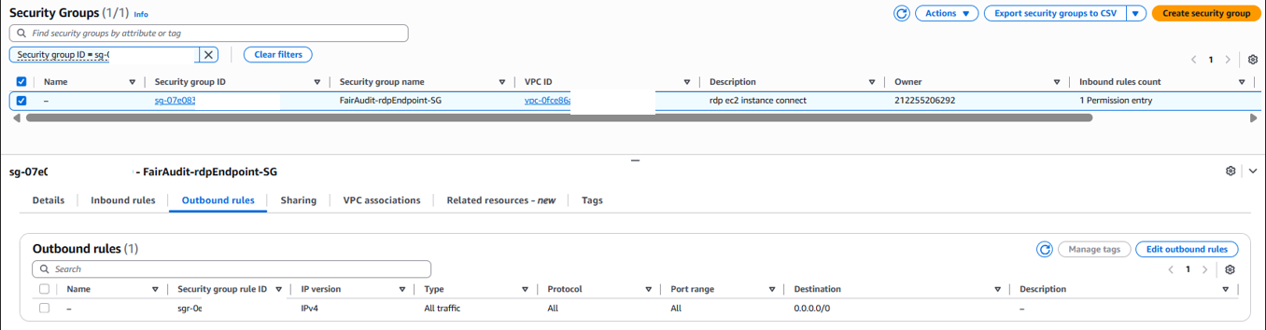
Tunnel ( EICE Endpoint )
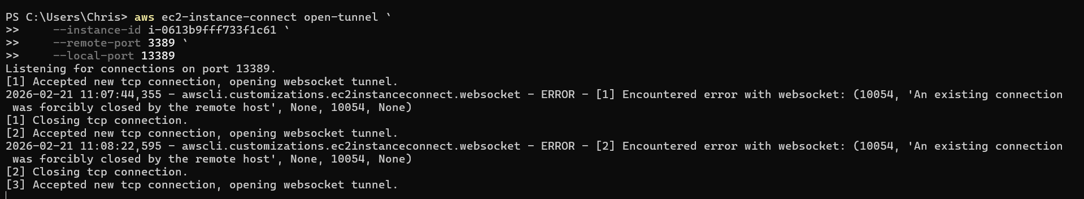
Connecting to FairAudit EC2 from my Laptop
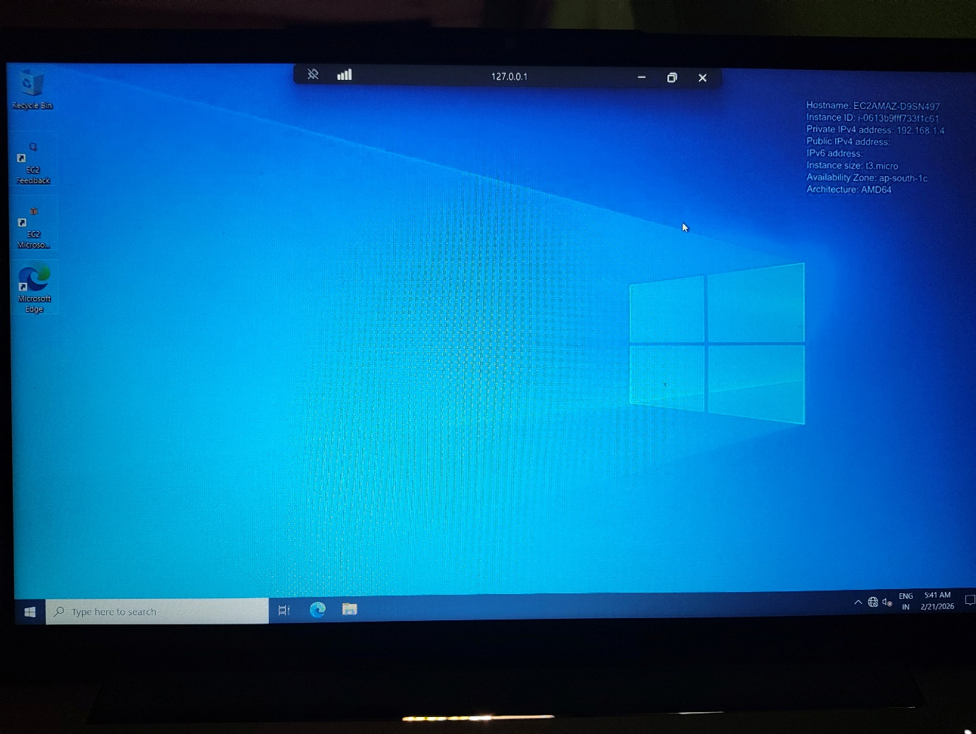

Connecting to chrisXYZ Audit EC2 from FairAudit EC2
